Excel: Patterns (Series)
Once you've established a pattern in a range of cells, you can essentially expand (extrapolate) that pattern out. For example, if you put the number 1 in the first cell, and the number 2 in the next, select both cells 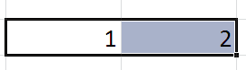and move your cursor to the bottom right hand corner of the last cell of the pattern. The cursor should change from a large plus sign to a small skinny plus sign . Now left-click and hold your mouse button and drag to the right and watch the pattern emerge. You should see in the next several cells the numbers 3, 4, 5, 6... This works both vertically and horizontally (but you can't do it at the same time). You'll need to know how to do this for the assignment below.

- Create a column heading in C1 named “Twos”. Create a range of cells to 30 places of the by 2’s pattern in column C. Color this column something that is easily seen.
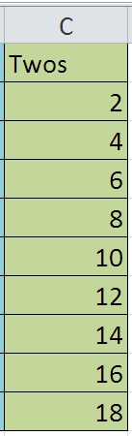

2. Create a column heading in D1 named “Fives”. Create a range of cells to 30 places of the by 5s pattern in column D. Color this column something that is easily seen.
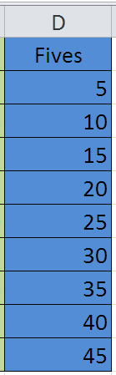
3.Create a column heading in E1 named “Days (abbr)”. Create a range of cells to 30 places of the Days (abbreviated) pattern in column E. Color this column something that is easily seen.
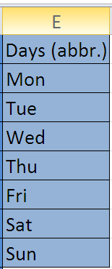
4.Create a column heading in F1 named “Days”. Create a range of cells to 30 places of the Days pattern in column F. Color this column something that is easily seen.
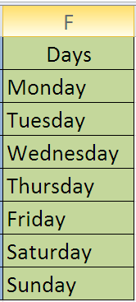
5.Create a column heading in G1 named “Months”. Create a range of cells to 30 places of the Months pattern in column G. Color this column something that is easily seen.
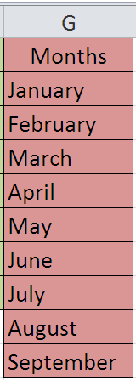
6. Create a range of cells to 30 places of a Times pattern in column H. Create a column heading in H1 named “Time”. Color this column something that is easily seen.
